CE 641
Fate and Transport Modeling of Ecosystem

Final Exam
Take Home Part

Shibo Wang
SW5QC@virginia.edu

December 12, 2007

Question 1:
Double the volumes of all 4 segments in Snug Harbor and rerun the WASP/EUTRO model (with tidal effect) and compare the results with your original results in chlorophyll a. Explain the comparison.
Answer:
Original Results after WASP/EUTRO Running
Segment 1  Chol a µg/L | Segment 2  Chol a µg/L | Segment 3  Chol a µg/L | Segment 4  Chol a µg/L
0.367 | 0.115 | 0.265 | 0.044
New Results after the Volumes of all the 4 Segments are Doubled
3.197 | 0.710 | 4.604 | 0.379
After running the EUTRO model, it is obvious that after the volume of the embayment is doubled, the chlorophyll a concentrations in each segment increase significantly. Since the algal growth better under larger volume, it can be concluded that the nutrient amount is not a controlling factor in this case. After examining and comparing the results of different parameters in the *.TRN file, with all the other values unchanged, the Retention Time, Exchange Time, and Total Retention Time doubles. The results are shown in the following table.

 | Segment 1 | Segment 2 | Segment 3 | Segment 4
Retention Time  1 X (days) | 0.112E+06 | 0.279 E+06 | 0.143E+06 | 0.106E+07
Retention Time  2 X (days) | 0.024E+06 | 0.558E+06 | 0.285E+06 | 0.211E+07
Exchange Time  1 X (days) | 0.894E+01 | 0.201E+02 | 0.887E+01 | 0.639 E+02
Exchange Time  2 X (days) | 0.179E+02 | 0.401E+02 | 0.177E+02 | 0.128E+03
Total Retention Time  1 X (days) | 0.113E+01 | 0.278E+01 | 0.139E+01 | 0.103E+02
Total Retention Time  2 X (days) | 0.227E+01 | 0.556E+01 | 0.278E+01 | 0.205E+02
It is well-known that mixing and circulation play a significant role in determining the potential of eutrophication in small embayments. Flushing time and retention time of salinity are good indicators of how long nutrients, such as phosphorous and nitrogen will stay in the embayment. Therefore, from the analysis of the flushing time and retention time from the EUTRO model, it can be deduced that the mixing and circulation under the 2-time-volume situation is much slower than the original condition, which means nutrients will spend more time (twice) in the embayment, providing a bigger chance for algae to uptake nutrients and grow. This also indicates that the flushing effect of tide is diminished, and the potential of eutrophication become more significant.
Also, from the 1st-order algal growth kinetic equation, similar conclusion can be reached:
C = C₀e^{kt}
where C represents the algal concentration; K represents the alagl growth rate; and t represents retention time.
With the retention time becoming longer, the algal concentration in the embayment will correspondingly increase.

Question 2:
Perform the mass transport modeling of salinity for Snug Harbor (not running the WASP/EUTRO model) using the following boundary conditions:
Segment 1: 0
Segment 3: 35 ppt
Segment 4: 35 ppt
Essentially, analytically solve for the salinity levels in the 4 segments by incorporating the advective and dispersive flows as stated in Lung et al. (1993). Use the original volumes.
Then change the boundary condition for segment 3 to -9999 and show that it would not change the results at all.
Answer:
The schematic graph showing the advective and dispersive flows are shown below:
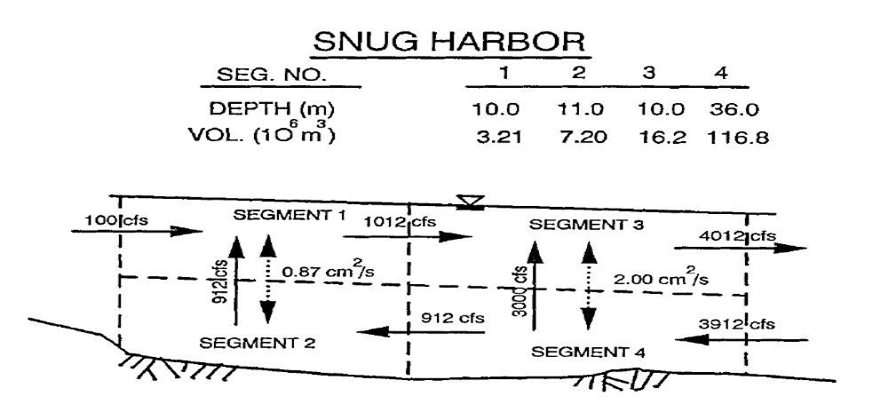
Fig.1 Two-layer mass transport in Snug Harbor (Lung, 1993)

Since the salinity is conservative, it can be calculated using the rationale of mass balance. The original volumes of the 4 segments are 3.21*10⁶ m³, 7.20*10⁶ m³, 16.2*10⁶ m³, and 116.8*10⁶ m³, respective.
First, take the whole embayment (all the 4 segments) as a system to do mass balance. Since the concentration of each spot in the embayment is constant, the output mass rate should be equal to the input mass rate.
Therefore,
35ppt * 3912cfs + 0ppt * 100cfs =4012 * C₃
where C₃ is the salinity level in segment 3.
Therefore, C₃ = 34.13ppt
Since the dispersion coefficient of segment 3 and 4 is 2.00 cm²/s, the surface area of 3-4 interface is 243222 m², average depth is (10.0+36.0)/2 = 23m,
Therefore,
Exchange flow rate Q₃₋₄ = (surface area * dispersion coefficient)/depth
= 2432222*2.00 * 10⁻⁴/23 = 21.1498 m³/s
= (1/0.028338) * 21.1498 = 746.341 cfs
Consider segment 4 and conduct mass rate balance of salinity:
3912cfs * 35ppt + C₃ * Q₃₋₄ = 3000cfs * C₄ + 912cfs * C₄ + Q₃₋₄ * C₄
where C₄ is the salinity level in segment 4
Therefore, C₄ = 34.86ppt
Likewise, consider segment 3:
1021cfs * C₁ + 3000cfs * C₄ + Q₃₋₄ * C₄ = Q₃₋₄ * C₃ + 4012cfs * C₃
where C₁ is the salinity level in segment 1
Therefore, C₁ = 31.43ppt
Since the dispersion coefficient of segment 1 and 2 is 0.87 cm²/s, the surface area of 1-2 interface is 501409 m², average depth is (10.0+11.0)/2 = 10.5m,
Therefore,
Exchange flow rate Q₁₋₂ = (surface area * dispersion coefficient)/depth
= 501409*0.87 * 10⁻⁴/10.5 = 4.1545m³/s
= (1/0.028338) * 4.1545 = 146.61 cfs
Take segment 2 for further consideration:
912cfs * C₄ + C₁ * Q₁₋₂ = 912cfs * C₂ + Q₁₋₂ * C₂
where C₂ is the salinity level in segment 2
Therefore, C₂ = 34.38ppt
The salinity of all the 4 segments are 31.43, 34.38, 34.13 and 34.86ppt, respectively.
It can be found that in the whole process of calculation, the boundary salinity of segment 3 (35ppt) is not used at all, therefore, when the boundary condition is changed from 35ppt to -9999ppt, there is no difference in the results. It is reasonable because there is no input from the Snug Harbor entering the embayment, the boundary condition of segment 3 has no effect on the salinity results.

